**Roger Earl Wolfe and Family**

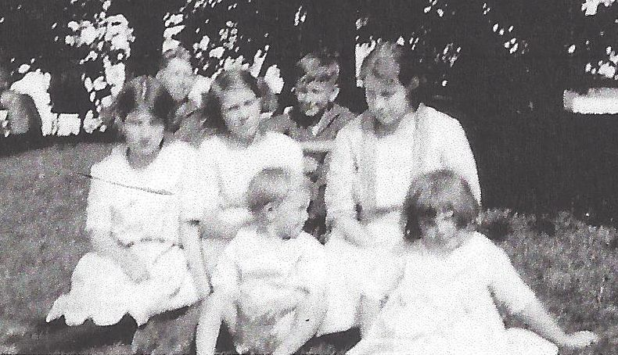

**Front Row: Roger and Josephine Ann Wolfe**

**Second Row: 2 girls unknown, and Dorothy Wolfe**

**Photo taken about 1924 (est.)**

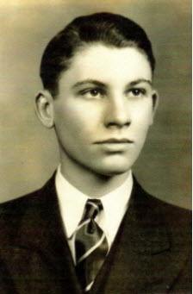

**Roger Earl Wolfe**

**Photo taken about 1938**